**Professional Behavior Document #1**

CIT360 - Jeremy Alkire

Brother Lawrence

1. **Interacting Professionally with the Instructor:**

We’ve not spoken too many times! You’ve responded to a few of my developer forum posts (I believe three exactly?), of which I only saw and responded to two.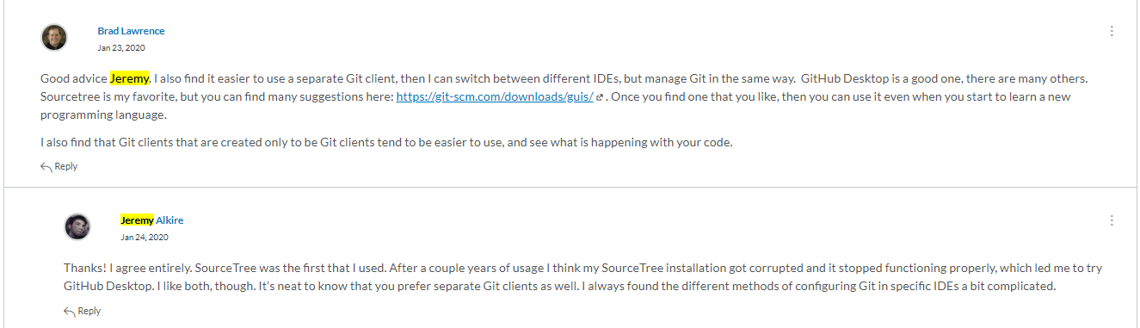

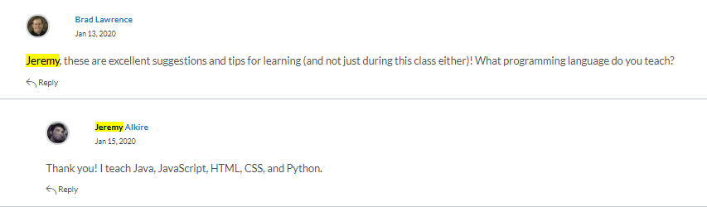

We also exchanged private messages recently when you reached out to me, and also once a while back in the semester when I spent the better part of a week without the ability to see, due to a lesion in my right eye.

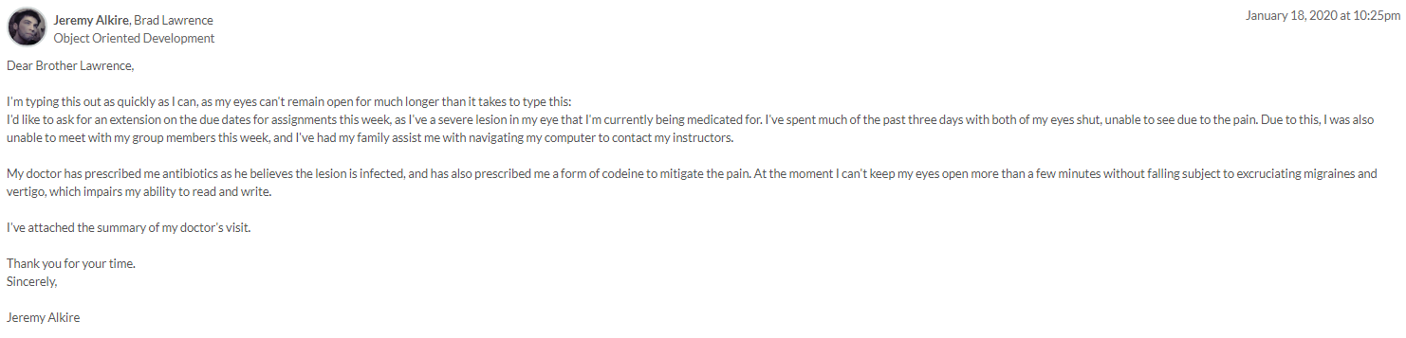

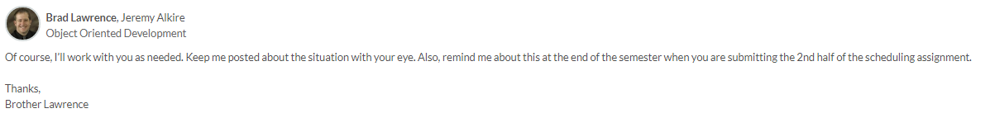

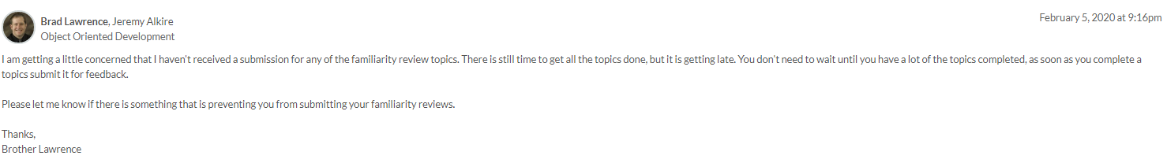

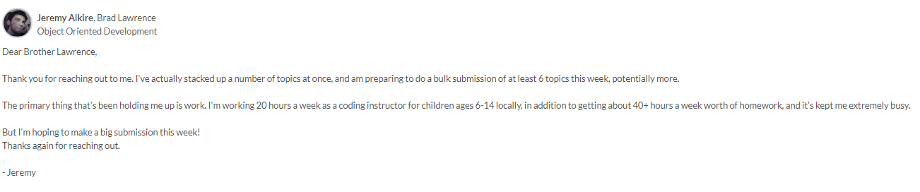

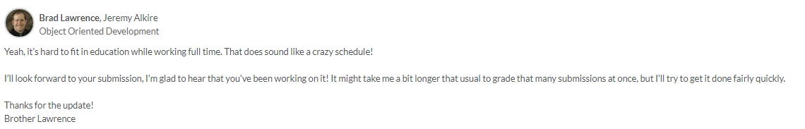

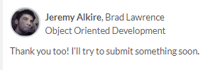

Earlier into the semester I mistook what was Yamika’s private topic schedule for being the team-teaching schedule, and sent you a message about that, but later recognized my mistake. So, I messaged you about a misunderstanding on my part. And I believe that’s been the extent of our interactions!

1. **Interacting Helpfully and Professionally with Other Teams:**

My interaction with other classmates (barring my group members) has been strictly on the developer forum. I sadly do not always have the time to post every day, unfortunately – which is something I want to still try and reconcile, but when I do post I try to be as helpful as I can. Here’s a long list of screenshots to showcase the times that I’ve interacted with and attempted to teach / help my classmates in the developer forum: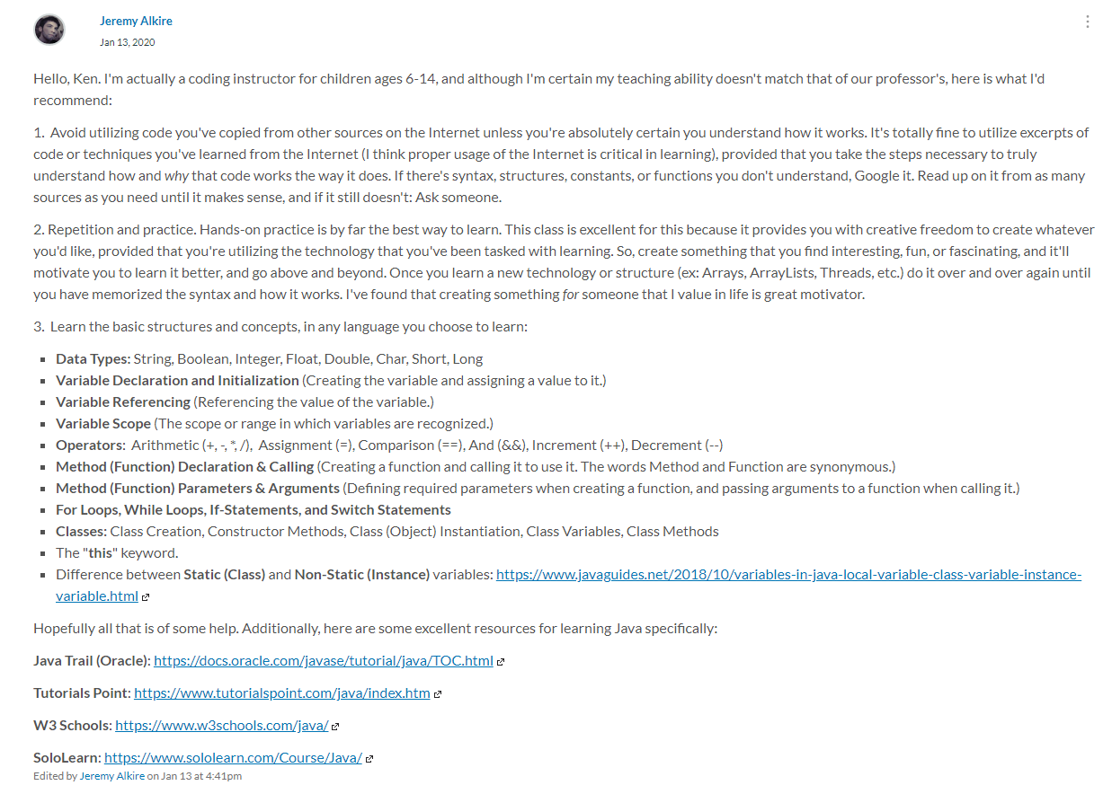

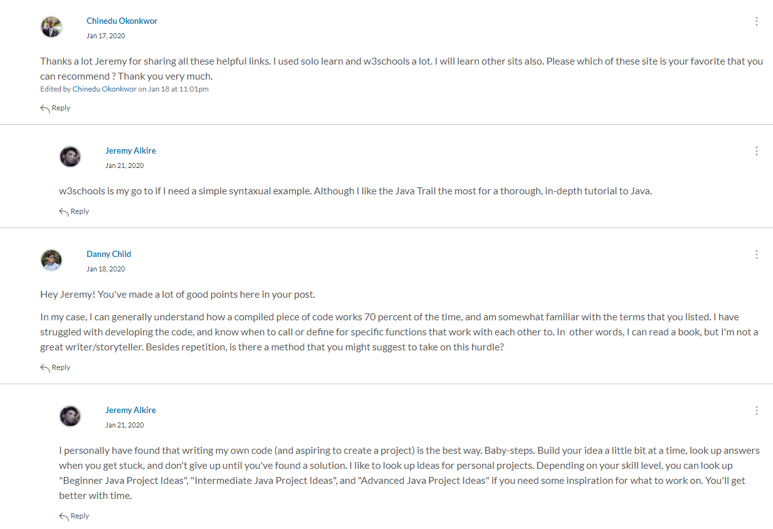

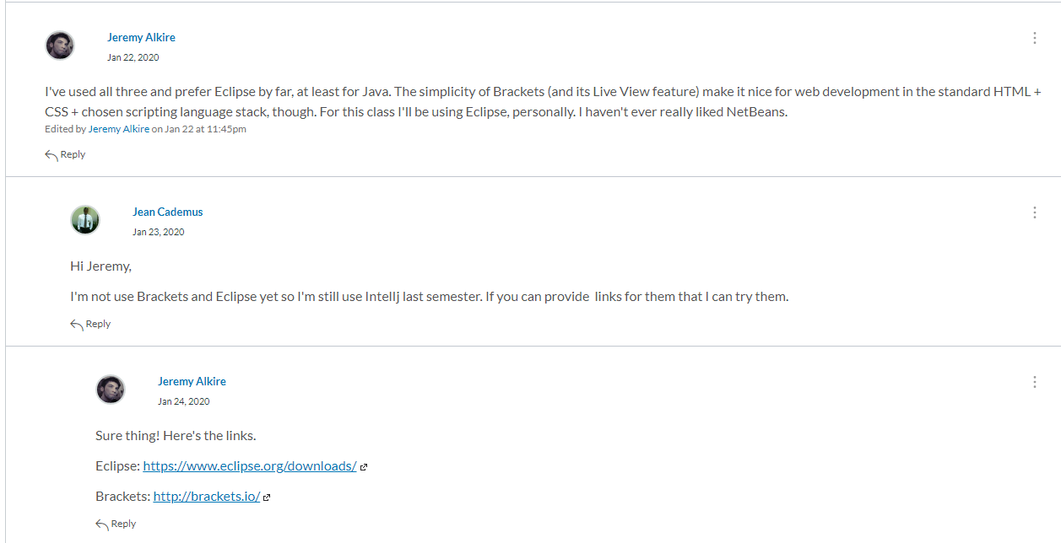

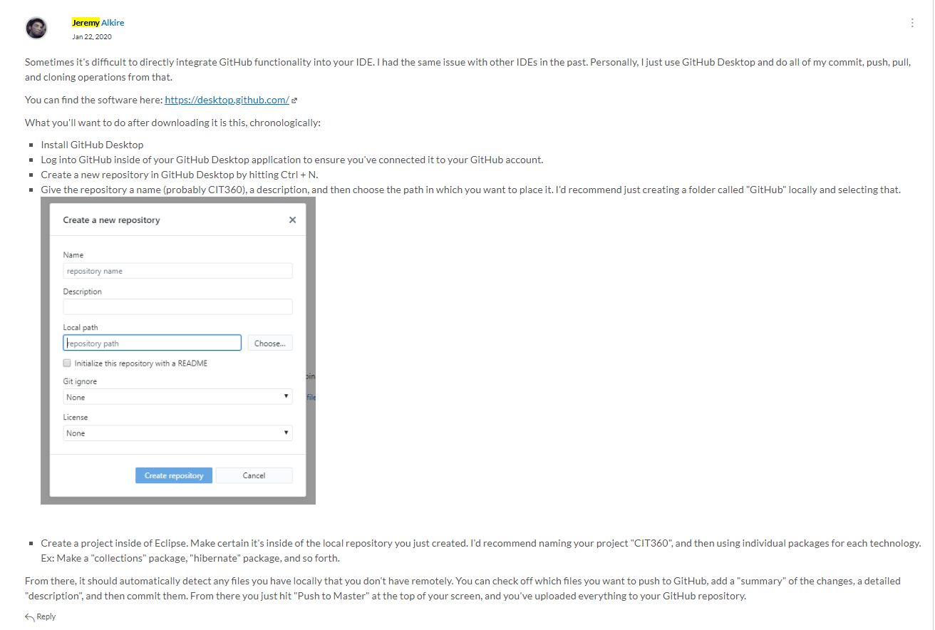

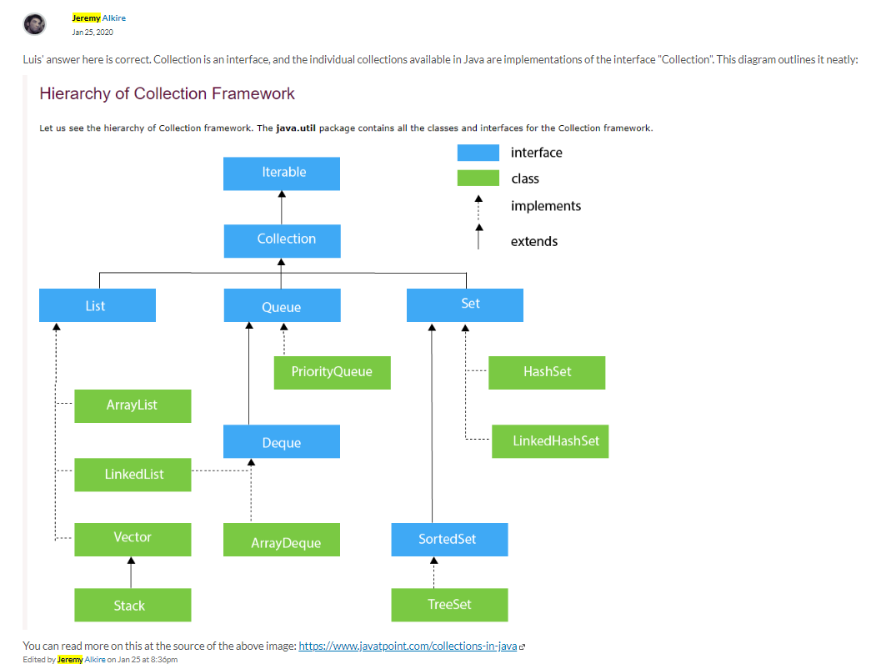

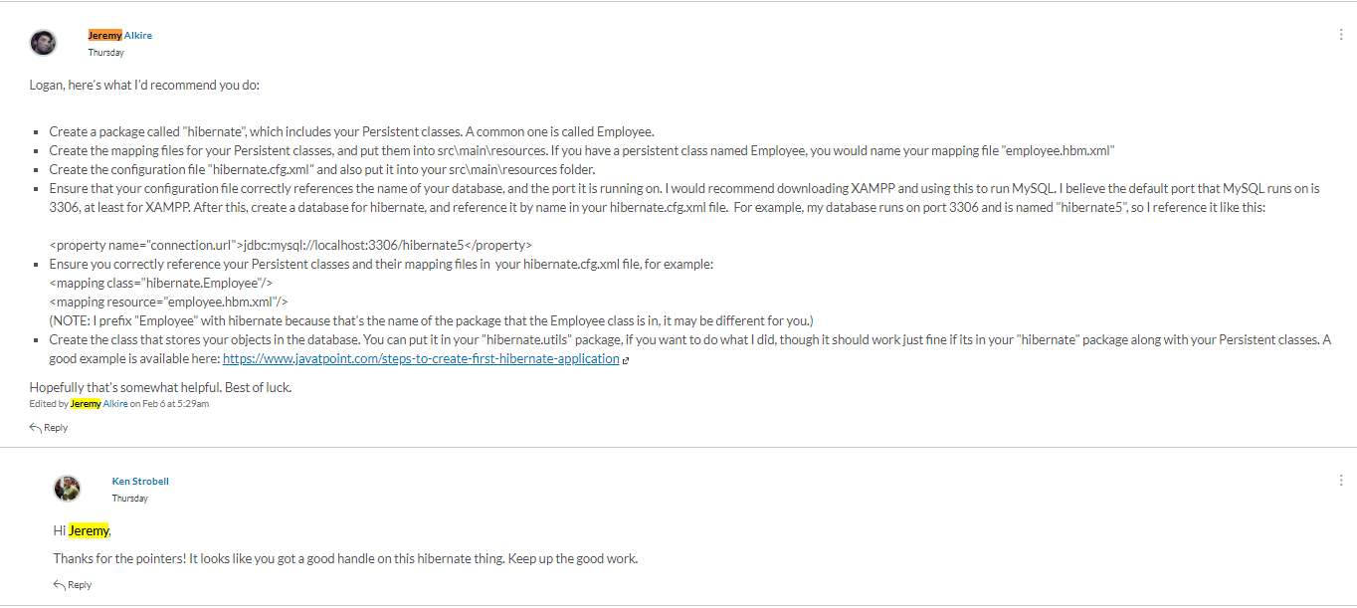

1. **Supporting the Team by Teaching, etc.**For the first few weeks of the semester my team members met during hours in which I was at work (at least once: even when I gave notice ahead of time that I’d be at work during their intended meeting time). As a result, I haven’t had too many opportunities to meet with them successfully, mostly due to my busy schedule. We’ve agreed to meet at 8:30 PM MST on Wednesday from now on, which should hopefully be doable in the future, but since I wasn’t able to attend our last meeting due to personal problems, I created a 25 minute lesson on Threads, Executors, and Runnables, and linked it to my group members in our Group Discussion Board.  
     
   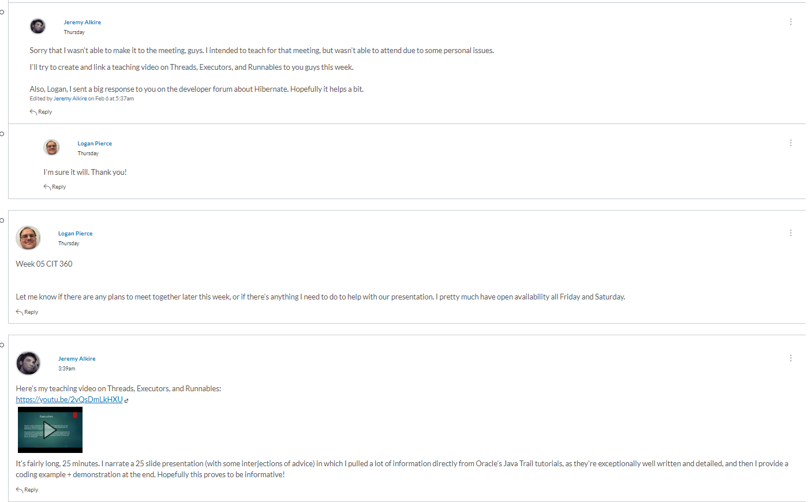

The full video is available here: <https://www.youtube.com/watch?v=2vQsDmLkHXU>

1. **Self-Reflection/Meta-Cognition:**

I think my shortcomings in the class so far are the following:

* Not always posting 3x a week on the developer forum on separate days.
* Not making it to the one team meeting that was scheduled during an hour in which I normally would have been available.
* Not submitting familiarity reviews frequently enough. I opted to do a bulk submission over many weeks rather than once every two weeks.

I’ll try to improve on these things in the future.

1. **Team's Agile Methodology:**

My team chose to use the Kanban approach to collaboration, although due to the chosen meeting times thus far I’ve not had a chance to collaborate with them on this. I think if a link was posted to some sort of collaborative Kanban board site, such as Trello, we could collaborate on this even without getting the chance to meet via video.

1. **Professional Scheduling Group:**

We established a specific meeting time to meet on each week quite recently. So our meeting times should be consistent and tenable for everyone from now on. Yamika’s Google Document that she posted early into the semester at current is what I’ve used to keep up with who intends to teach when.